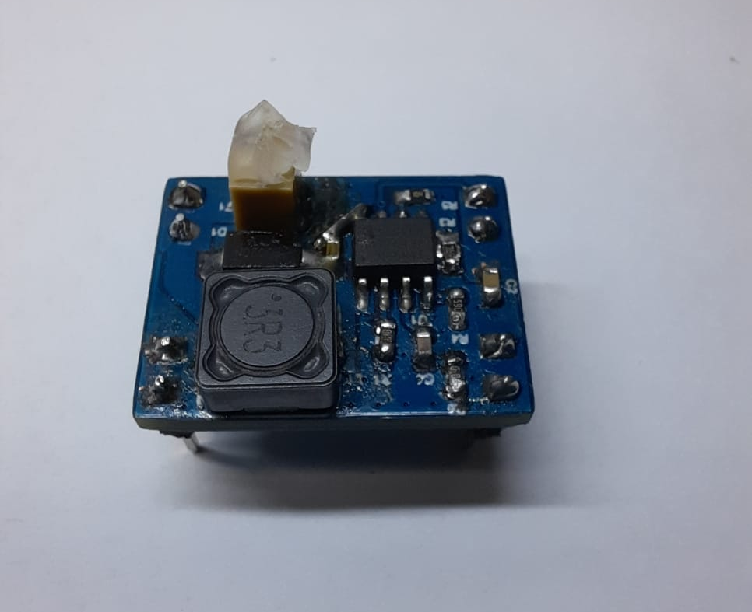
SMPS Module, in Partnership With JLCPCB
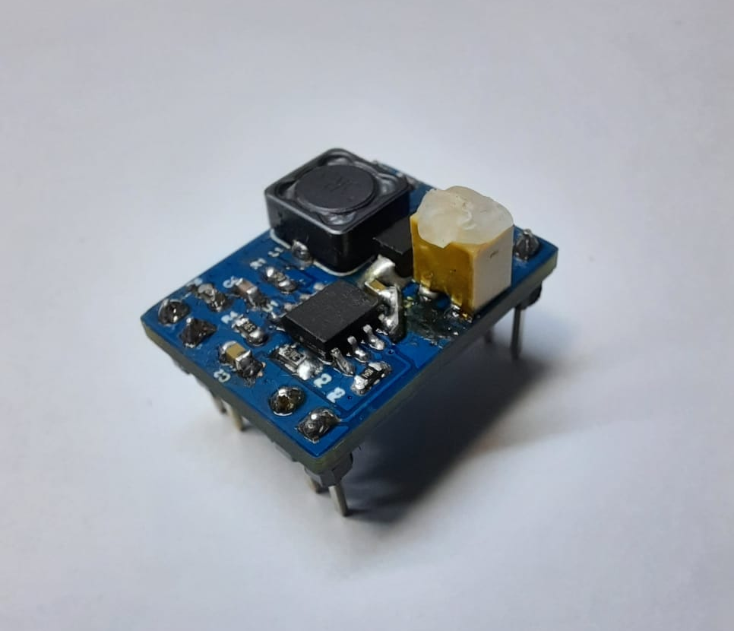
Story
We are a community that aims to make the most efficient vehicles by using alternative energy sources for a sustainable world and future generations. Our club, which was founded by Yıldız Technical University students, continues its activities with the intense work of students from different disciplines. Our club, which set out with the slogan "Save Your Energy", aims to add value to the world both technically and socially.
The AESK team participates in national and international competitions in line with its goals and objectives. Our vehicles produced by our team took part in Formula G and Efficiency Challenge competitions organized by TÜBİTAK. These vehicles, which work with solar and electric energies, have achieved a great success by getting degrees from the competitions.
Our club, which always aims for the better, continues to work with great enthusiasm and devotion.
In this process, JLCPCB has been one of our supporters in reaching our goal.

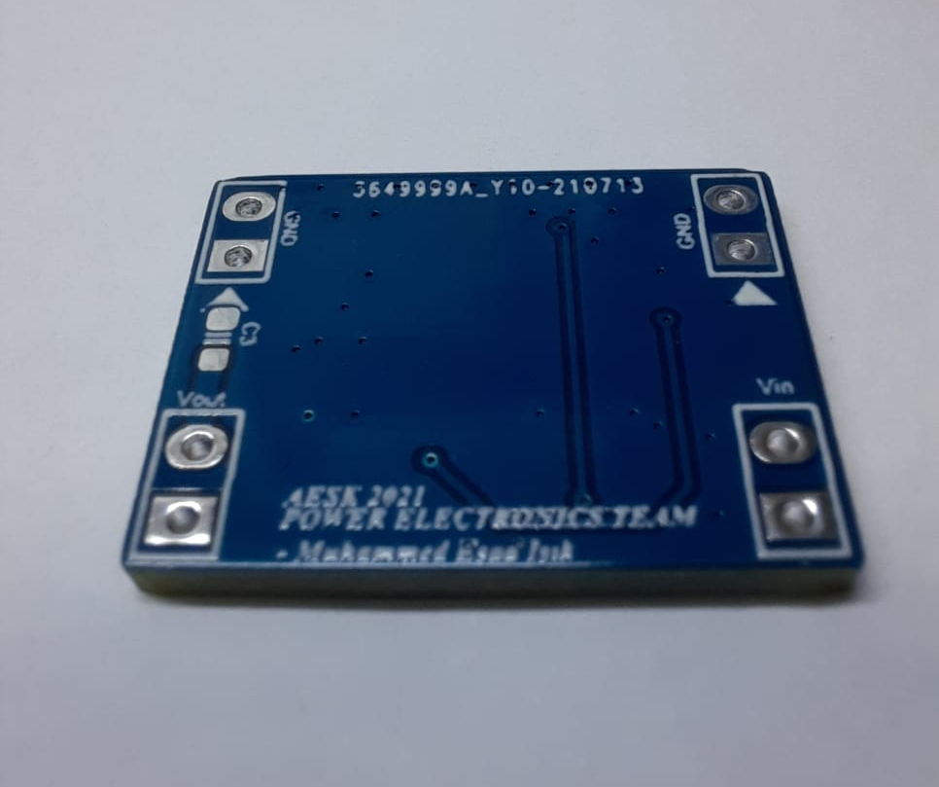
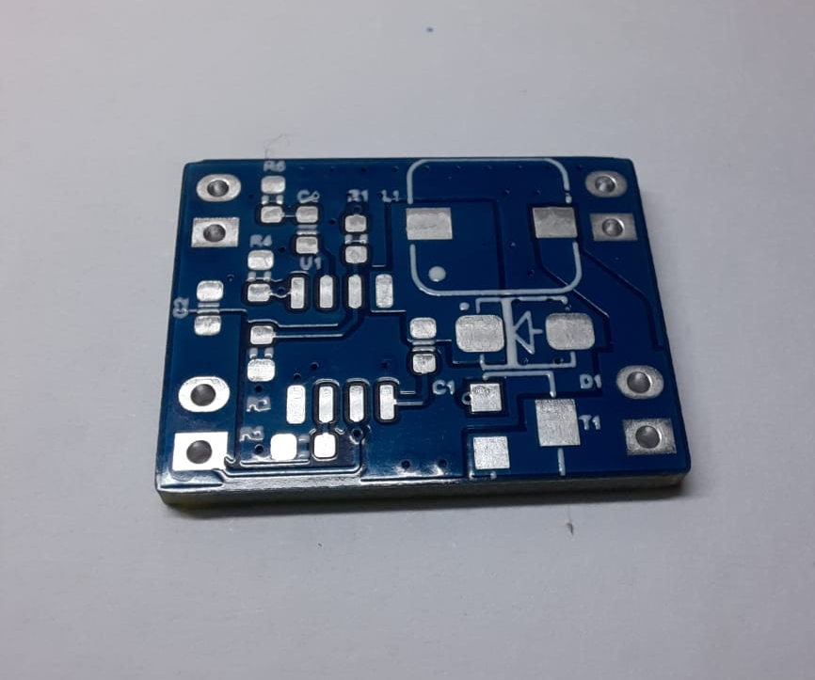
Step 1: The SMPS (Switch Mode Power Supply )
The 'Efficiency Challenge' is an event related to the races held in the Electromobile and Hydromobile categories and vehicles powered by electricity and hydrogen energy. In this way, it is aimed to increase domestic production, to enable university students to research alternative energies, to follow the developments in the world and to gain experience.
This module we have designed is used to adjust the tension on the part where it is used on the vehicle. It reduces the input voltage between 12V-5V and transfers it to the output. It acts as a Buck Converter. It can be adjusted with the potentiometer on the desired output voltage value.
It is also called a regulator.

Step 2: The Circuit
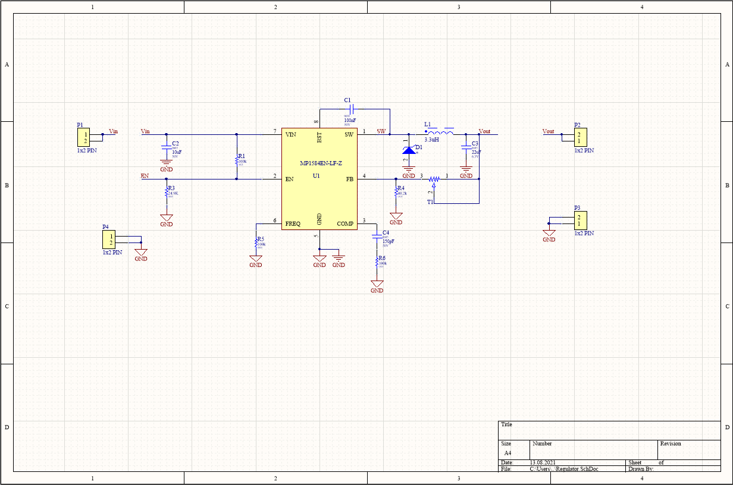
To obtain the desired voltage value, we have:
- MP1584EN
- A Potentiometer providing variable resistance
- Inductor

Step 3: Making the Board
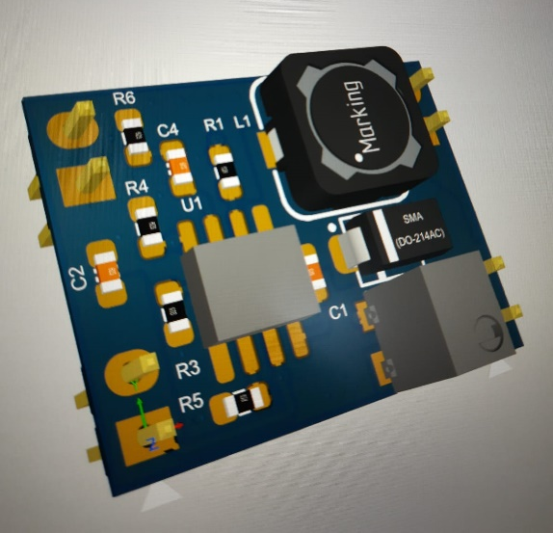

First, the parts were defined by the electrical department and the design of the board was made.
They designed a board using Gerber. Once everything was put up together, we just had to upload it on JLCPCB's website to have it made custom.
To conclude, we want to give a huge thanks to JLCPCB which helps us a lot during theses challenging times. They made the discussion very easy and helped us make this PCB in no time.

